Subject Line: Join MAD for a fall day trip to Hudson, NY
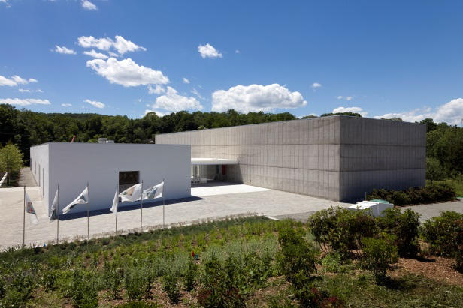
MAD Members Hudson Valley Day Trip
Thursday, October 18, 2018

MAD members only
$280 per person (price includes lunch and admission fees)
To register, please download the registration form here. We must receive your completed registration form and full payment no later than Tuesday, October 9, 2018. Please email the completed form to Lucig.Kebranian@madmuseum.org or fax it to 212.299.7701. For trip-related questions, please contact Lucig Kebranian at 212.299.7732.

Join MAD for an art-filled getaway to the Hudson Valley this fall. We have planned an exciting itinerary that includes an exclusive visit to the studio of noted artist Jacob Hashimoto http://jacobhashimoto.com/, a private tour of newly opened Magazzino Italian Art https://www.magazzino.art/, and a docent-led tour of Storm King Art Center https://stormking.org/.

8:00 am: Guest arrival at the Museum
Guests will meet at MAD at 2 Columbus Circle.
8:15 am: Prompt departure from the Museum
Guests will travel via private motor coach.
Jacob Hashimoto
Jacob Hashimoto was born in Greeley, Colorado, and is a graduate of the School of the Art Institute of Chicago. Using sculpture, painting, and installation, he creates complex worlds from a range of modular components, including bamboo-and-paper kites, model boats, and Astroturf-covered blocks. Hashimoto has been featured in solo institutional exhibitions at the Museum of Contemporary Art, Los Angeles; the Museum of Contemporary Art of Rome; Wäinö Aaltonen Museum of Art, Turku, Finland; Fondazione Querini Stampalia, Venice; and the Los Angeles County Museum of Art, among many others.

Magazzino Italian Art
Co-founders Nancy Olnick and Giorgio Spanu will guide the group through the twenty-thousand-square-foot warehouse art space, which is devoted to postwar and contemporary Italian art from the Olnick Spanu Collection. The current exhibition, Arte Povera: From the Olnick Spanu Collection, presents a comprehensive panorama of the artistic practice of twelve artists associated with the Arte Povera movement: Giovanni Anselmo, Alighiero Boetti, Pier Paolo Calzolari, Luciano Fabro, Jannis Kounellis, Mario Merz, Marisa Merz, Giulio Paolini, Pino Pascali, Giuseppe Penone, Michelangelo Pistoletto, and Gilberto Zorio.

Lunch

Storm King Art Center
Set on over five hundred acres of fields, hills, and woodlands, Storm King Art Center is a well-loved destination for enthusiasts of art and nature. This is an opportunity to stroll among a breathtaking collection of large-scale sculptures by acclaimed artists such as Alexander Calder, Andy Goldsworthy, Roy Lichtenstein, Maya Lin, Louise Nevelson, and Isamu Noguchi.

7:00 pm: Projected return to 2 Columbus Circle*

RESERVATION AND ITINERARY POLICY:
This trip may be limited to 25 participants, and reservations will be taken in order of receipt. The itinerary provided is provisional. In the event that any changes are made, be assured that the quality of the program will be maintained. The trip includes transportation via private coach; pickup and drop-off at MAD; curatorial comment; lunch; gratuities; administration costs; and tour preparation. We encourage you to wear comfortable shoes and dress appropriately for the weather.
CANCELLATIONS AND REFUNDS:
Participants may cancel their reservation through Tuesday, October 9, 2018. After that date, the trip is 100% non-refundable. MAD reserves the right to cancel the trip if there are fewer than 15 participants or due to unforeseeable circumstances. Upon reservation, participants assume responsibility for their physical abilities to travel and must notify the Museum of any health or physical conditions and/or allergies (including dietary restrictions) that may hinder their ability to fully participate in this trip.
* Please note that we cannot guarantee an exact return time to the Museum, due to the potential for traffic and unforeseen road conditions. All participants will return to MAD at 2 Columbus Circle. No stops will be made prior to arrival at the Museum.

