PLAN A

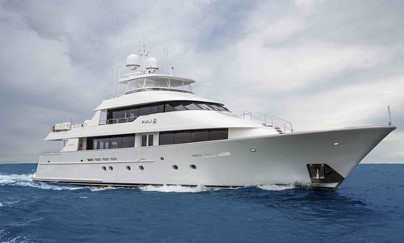

SPECIFICATIONS  - Length: 39.62 meters (130')  - Beam: 7.92 meters (26')  - Draft: 2.13 meters (7')  - Number of crew: 8  - Built: 2007  - Builder: Westport  - Naval architect:  - Flag: U.S.  - Hull construction: Aluminum  - Hull configuration: Displacement  - Air conditioning, Deck Jacuzzi, Gym/exercise equipment, Stabilizers at anchor, Stabilizers underway, Wi-Fi connection on board | EQUIPMENT  - Engines: 2x MTU 12V 4000 M90 @ 2735hp Diesel  2X Northern Light Generators 65kw rebuilt 2014  - Cruising speed: 19  - Fuel consumption: 120 US Gall/Hr
ACCOMMODATION  - Number of cabins: 5  - Cabin configuration: 4 Double, 1 Twin  - Bed configuration: 3 King, 1 Queen, 2 Single  - Number of guests: 10 | WATER SPORTS  - Tenders + toys: 35' Scout Center Console (Towed)  (2) Wave Runners  (2) 2 Man Kayaks  Adult Water Skis, Knee board, Wake board  (2) Towing Tubes  Floating Mats,  Snorkel Gear - Adults & Kids  (6) Fishing Rods, Deep Sea Fishing  BBQ  Swim Platform & Boarding Ladder  Deck Shower  Sun Awnings

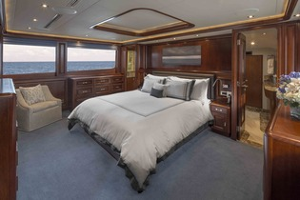  Master Stateroom | 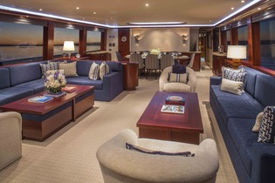  Main Salon
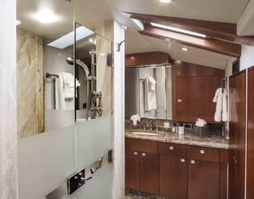  Master Bath | 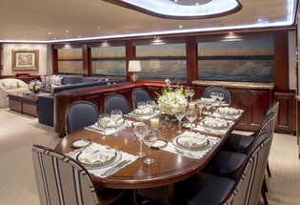  Formal Dining & Main Salon
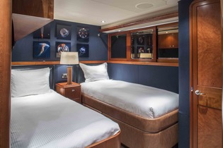  Twin Guest Stateroom | 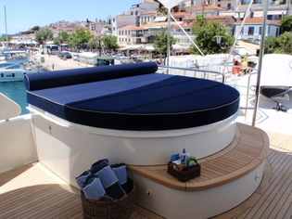  Sun Deck Hot Tub
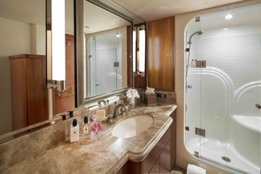  Guest Bath | 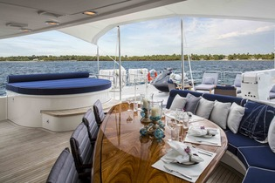  Sun Deck Dining & Hot Tub
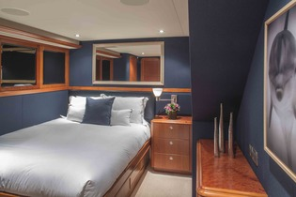 | 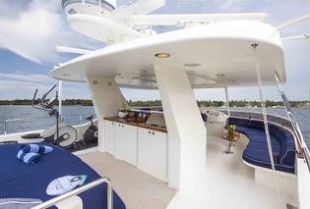  Sun Deck Helm & Seating
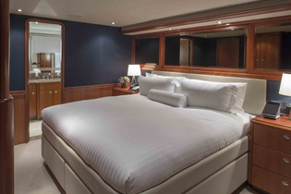 | 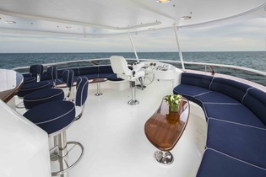  2nd Helm & Top Deck Bar
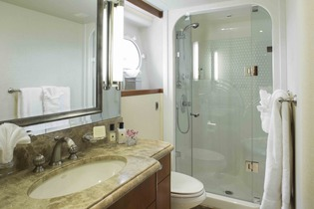  Guest Bath | 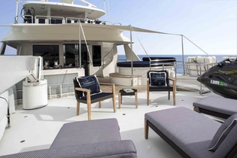  Sky Lounge Aft Deck
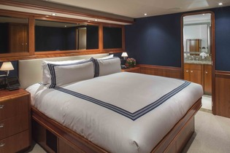  VIP Guest Stateroom | 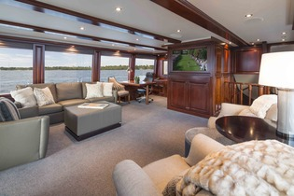  Sky Lounge
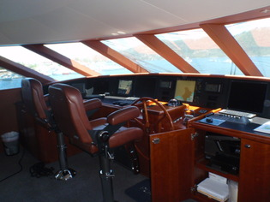  Wheelhouse | 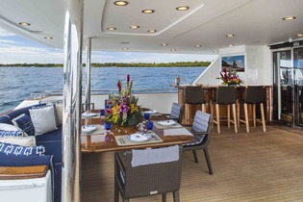  Sky Lounge Aft Deck
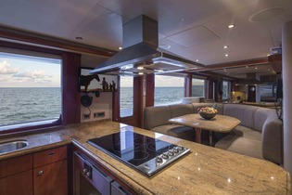
Galley

This document is not contractual. All specifications are given in good faith and offered for informational purposes only. The publisher and company do not warrant or assume any legal liability or responsibility for the accuracy, completeness, or usefulness of any information and/or images displayed. Yacht inventory, specifications and charter prices are subject to change without prior notice. None of the text and/or images used in this brochure maybe reproduced without written consent from the publisher.

